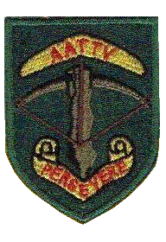
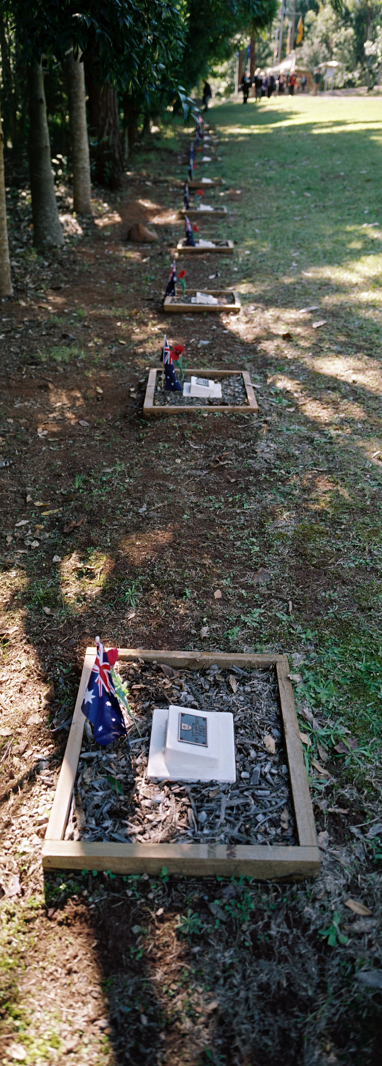

The Row of Memory
In Honour of the Fallen

In remembrance
of the fallen

AATTV 50th BIRTHDAY REUNION
BRISBANE 27-29 JULY 2012

Welcome! On behalf of the Queensland Branch of the AATTVA I bid all delegates a warm welcome to Brisbane to celebrate The Team’s 50th Birthday Reunion and Memorial Service, here in Brisbane and at our Memorial Grove, Land Warfare Centre Canungra.

We trust your stay with us over the three day event will be enjoyable and indeed memorable.

To assist delegates with each day’s activities please refer to the attached Event Briefs.

As well, members of my committee will be on hand to assist with all matters, whether big or small. They may be recognised at the Welcome Civic Reception by wearing white polo shirts with the Team Logo and they are:

John Gibson Frank Reid Mick Smith
Peter Conway Allen Edwards

Looking forward to catching up with you all over the next few days!

Persevere

John Gibson
President
AATTVA (Qld Br) inc

EVENT BRIEF - CIVIC RECEPTION
FRIDAY 27 JULY 2012

The Civic Reception and Cocktail Party is to be held at Queensland’s Parliament House on Friday evening to formally welcome delegates to Queensland and Brisbane by our State Premier, the Hon Campbell Newman MP and the Lord Mayor of Brisbane, Cr Graham Quirk.

The following information should be noted:

Timings: Registration 1630 -1730 hours. Name Tags and Gift Pack issued
Cocktail Party. 1730-1930 hours.

Dress: Smart Casual

TRANSPORT DETAILS

Serial | Pick Up Point | Coach  Number | Guide | Time of  Departure
1 | Sebel Hotel – from immediately in front of Hotel entrance | Three  Four | Allen  Edwards | 1615
2 | Novatel, Ibis and William George Hotels – from the Lane between the Ibis and Novatel Hotels | Five | Frank  Reid | 1615
3 | Rydges and Mantra Hotels – from the coach parking zones adjacent to the Brisbane Convention and Exhibition Centre | One  Two | John  Gibson | 1615

Glenelg St Pick Up Point; The Glenelg Street Pick Up point adjacent to the BCEC provides transport to all destinations for delegates staying at Rydges and Mantra hotels and for delegates making their own way from either South Brisbane and Southbank Railway Stations, or by bus to the BCEC.

Coaches shall return to the pick up locations departing parliament house at 1945 hrs. PLEASE ENSURE YOU BOARD THE SAME COACH NUMBER THAT PICKED YOU UP – There will be guides to assist.

Delegates wishing to make their own way to Parliament House may do so with transport and parking under own arrangements. A guide will be at Parliament House to direct you to the Registration area.

Delegates not attending the Civic Reception shall receive their Name Tag and Gift Pack at the Memorial Service on Saturday 28th July.
Those not wishing to return by coach and perhaps visit the city are to make their way back to hotel under own arrangements.

Delegates are to report to the ‘Alphabetically Designated Check In’ counters to register and collect their Name Tag.
Do not forget to collect your gift package on departure from the reception!

Coach Location pickup points are shown on attached map!

EVENT BRIEF – MEMORIAL SERVICE
LAND WARFARE CENTRE – CANUNGRA - SATURDAY 28 JULY 2012
5
The following information should be noted:

Timings:
TRANSPORT DETAILS

Serial | Pick Up Point | Coach  Number | Guide | Time of  Departure
1 | Sebel Hotel – from immediately in front of Hotel entrance | Four, Five  Six | Allen  Edwards | 0815
2 | Novatel, Ibis and William George Hotels – from the Lane between the Ibis and Novatel Hotels | Three | Frank Reid | 0815
3 | Rydges and Mantra Hotels – from the coach parking zones adjacent to the Brisbane Exhibition and Convention Centre | One,  Two | John  Gibson | 0815

.
For those travelling by own means you take the first entry into the base off Beechmont Rd. You will then be directed by a guide into to a parking bay “the FE Yard” then onto the grove by a shuttle bus departing every 15 minutes from 0930 hrs. Please ensure you are at LWC in time. The last shuttle bus will depart at 1030 hours sharp.

Photo ID will be required for all delegates, family members and drivers

Memorial Service commences at 1100 hours

Lunch: 1200 – 1330 hours.

For those not staying for lunch and need to return to the parking bay a shuttle bus will operate from 1200 hours. Coaches return to Brisbane 1345 hours – ensure you board the right Coach Number. Those travelling by own means, and staying for lunch, will be returned to the parking bay by coach and shuttle bus.

Dress: Jacket and Tie with large Medals as appropriate. Hats, Bonnets and sturdy walking shoes are advised. Ladies smart casual in line with the climate.

Health and Safety Concerns

Seating There will be a mix of seating at the Grove and delegates will be ushered to their seats. Be advised that some delegates may have standing room only and ushers may well be selective towards allocating seats.

Fire
Evacuation: Coach Guides and other selected personnel will act as fire wardens. Delegates will be warned of the forming up and evacuation routes in the event of fire breakout. Senior cadets and appointed delegates will be there to assist the elderly

if required. The Emcee for the Memorial will provide a brief for fire evacuation immediately prior to the Wreath Laying Ceremony.

An attached sketch map of the Grove shows assembly points and evacuation routes in the event of fire outbreak.

The Grove: There will plenty of opportunity for visitors attending the Grove for the first time to tour the grove and in particular locate the tree dedicated to their Team Member. Of particular interest are Dedication Plaques at the base of many trees. There is a Tree Location Board showing where each soldier’s tree is .located. Although the Grove lanes have been cleared of rock and debris care should be taken and elderly members may need assistance.

In addition you will find attached a card showing the location of your tree by row and tree number.

Ambulance: An ambulance will be stationed on site.

Smoking Smoking within the confines of the memorial grove is prohibited

If this is the first event that you are attending please report to the Check In Registration Counter located at the rear of the CAN Nha Memorial Building to collect your Name Tag and Gift Pack

EVENT BRIEF – FORMAL DINNER
BRISBANE CONVENTION AND EXHIBITION CENTRE
SATURDAY 28 JULY 2012

The following information should be noted:

Coach Brisbane City Council Buses are being used for ferrying guests from the
Transport Sebel Hotel and The Novotel Hotel at the pick up points and timings shown below.
Busses will depart the BCEC for return to the city Hotels and South Brisbane Railway Station at 2230 hours.

Serial | Pick Up Point | Coach  Number | Guide | Time of  Departure
1 | Sebel Hotel – from immediately in front of Hotel entrance | One, Two  Three  Four | Allen Edwards | 1830
2 | Novatel, Ibis and William George Hotels – from the Lane between the Ibis and Novatel Hotels | Five  Six | Frank  Reid | 1830

Timings: 1900 for 1930 hrs
1945 hrs – Dinner Served – all beverages (other than spirits) are complimentary up until 2200 hrs.

Coach Brisbane City Council Buses are being used for ferrying guests from the
Transport Sebel Hotel and The Novotel Hotel at the normal pick up points.
point at 1830 hours sharp.

Busses will depart the BCEC for return to the city Hotels and South Brisbane Railway Station at 2230 hours.

Residents staying at the Rydges and Mantra Hotels may take the short walk to the BCEC – Guides will assist. There is wheel chair access direct from Rydges to the BCEC by a commuter undercover hallway. Guides will assist with wheel chair access.

Delegates making their own way to the BCEC are advised that parking is available at the BCEC.

Delegates arriving at South Brisbane Railway Station are to exit on the Grey St side and an entrance to the Brisbane Convention and Exhibition Centre is but a short walk from the Station. Or alternatively delegates arriving from the South may exit at Southbank Railway station and enter the BCEC from the Merivale Street entrance.

Dress: Gents: Lounge suit with Miniature Medals as appropriate
Ladies: After Five Wear

EVENT BRIEF – BRISBANE RIVER CRUISE
THE KOOKABURRA QUEEN RIVER BOATS
EAGLE STREET PIER – SUNDAY 29 JULY 2012

The following information should be noted:

Day three is another chance to catch up, chat and enjoy a Brisbane River cruise. Both the Kookaburra Queen River Boats will be used for the Cruise and delegates will be equally divided to each boat. Kookaburra Queen One will host the National Board Meeting.

There will be plenty of time to catch up with others as the Boats will dock, after lunch and the cruise, at the Pier for another hour where delegates may cross over between boats.

Transport
TRANSPORT DETAILS

Serial | Pick Up Point | Coach  Number | Guide | Time of  Departure
1 | Sebel Hotel – from immediately in front of Hotel entrance | One, Tow  Three | Allen  Edwards | 1000
2 | Novatel, Ibis and William George Hotels – from the Lane between the Ibis and Novatel Hotels | Six | Frank  Reid | 1000
3 | Rydges and Mantra Hotels – from the coach parking zones adjacent to the Brisbane Exhibition and Convention Centre | Four  Five | John  Gibson | 1000

Delegates making their own way to the Pier are advised that paid parking exists at the Pier, but be advised Sunday is also a Market Day, throughout the Pier complex, and there may difficulties on where parking may be available.

Cruise Delegates will be issued with a boat boarding pass and we board at 1030 Timings: hours. The boats embark at 1100 hrs with a buffet lunch served from 1200 hours. Your boat boarding pass for you and your guests in attached.

Lunch is a variety of seafood, hot dishes, salads and deserts. All beverages are complimentary (with the exception of spirits) until 1500 hours. The cruise terminates at around 1400 hours and we are allowed to remain on board until 1500 hours. This is an opportunity to cross over and meet other delegates.

National The National Meeting convenes at 1100 hours on the top deck of
Meeting: Kookaburra Queen One

YOUR THOUGHTS – FOR A FUTURE REUNION

Dear Delegate

Now that our Reunion is over we would like your comments, ideas, criticism and the like to pass on to the organizing committee of the 55th Reunion – should such an event take place.

All comments appreciated and they shall be passed on as written.

Thank you

___________________________________________________________

Delegate______________________
(non-obligatory)

Please forward to:

Mick Smith
Secretary AATTVA (Qld Br inc)
Lot 1/472 Cedar Creek Rd
SAMFORD QLD 4520

